Normalisasi Database

* **ERD normalisasi**

**ERD KAMAR**

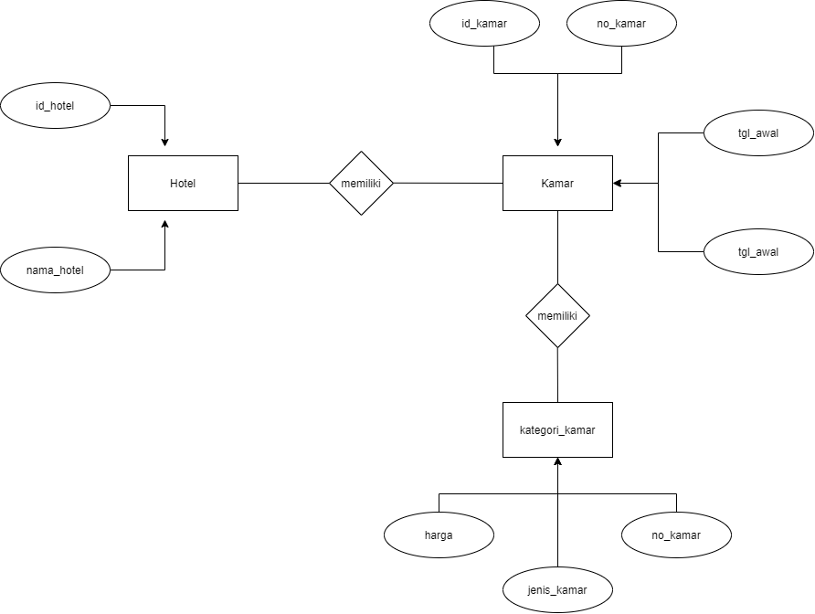

|  |  |  |  |  |  |  |  |  |
| --- | --- | --- | --- | --- | --- | --- | --- | --- |
| Id_pelangan | Nama_pelangan | No_kamar | Jeinis_kamar | harga | Id_transaksi | Tgl_awal | Tgl_akhir | total |
| 2021 | Angga Yunanda | 001 | VIP | 2.000.000 | A0001 | 10-03-2021 | 20-03-2021 | 20.000.000 |
| 2022 | Husain Basyaiban | 004 | Keluarga | 1.000.000 | A0002 |  | 25-05-2021 | 10.000.000 |
| 2023 | Iqbaal Ramdhan | 009 | VIP | 1.000.000 | A0003 | 06-05-2021 | 12-05-2021 | 14.000.000 |
| 2024 | Maudy Ayunda | 012 | Standart | 500.000 | A0004 |  |  | 1.500.000 |
| 2025 | Wilona | 010 | Standart | 500.000 | A0005 |  | 10-07-2021 | 2.000.000 |

* **Bentuk Normal Pertama (1NF)**

|  |  |  |  |  |  |  |  |  |
| --- | --- | --- | --- | --- | --- | --- | --- | --- |
| Id_pelangan | Nama_pelanggan | No_kamar | Jeinis_kamar | harga | Id_transaksi | Tgl_awal | Tgl_akhir | total |
| 2021 | Angga Yunanda | 001 | VIP | 2.000.000 | A0001 | 10-03-2021 | 20-03-2021 | 20.000.000 |
| 2022 | Husain Basyaiban | 004 | Keluarga | 1.000.000 | A0002 | 20-05-2021 | 30-05-2021 | 10.000.000 |
| 2023 | Iqbaal Ramdhan | 009 | VIP | 1.000.000 | A0003 | 06-05-2021 | 12-05-2021 | 14.000.000 |
| 2024 | Maudy Ayunda | 012 | Standart | 500.000 | A0004 | 01-07-2000 | 03-07-2021 | 1.500.000 |
| 2025 | Wilona | 010 | Standart | 500.000 | A0005 | 08-07-2000 | 11-07-2021 | 2.000.000 |

* **Bentuk Normal Kedua (2NF)**

|  |  |  |
| --- | --- | --- |
| Id_pelangan | Id_transaksi | total |
| 2021 | A0001 | 20.000.000 |
| 2022 | A0002 | 10.000.000 |
| 2023 | A0003 | 14.000.000 |
| 2024 | A0004 | 1.500.000 |
| 2025 | A0005 | 2.000.000 |

|  |  |
| --- | --- |
| Id_pelangan | Nama_pelangan |
| 2021 | Angga Yunanda |
| 2022 | Husain Basyaiban |
| 2023 | Iqbaal Ramdhan |
| 2024 | Maudy Ayunda |
| 2025 | Wilona |

|  |  |  |  |  |  |
| --- | --- | --- | --- | --- | --- |
| Id_transak  si | Tgl_awal | Tgl_akhir | No_kamar | Jeinis_kam  ar | harga |
| A0001 | 10-03-2021 | 20-03-2021 | 001 | VIP | 2.000.000 |
| A0002 | 20-05-2021 | 25-05-2021 | 004 | Keluarga | 1.000.000 |
| A0003 | 06-05-2021 | 12-05-2021 | 009 | VIP | 1.000.000 |
| A0004 | 01-07-2000 | 03-07-2021 | 012 | Standart | 500.000 |
| A0005 | 08-07-2000 | 11-07-2021 | 010 | Standart | 500.000 |

* **Diagram Ketergantungan Fungsional**

Nama_pelangan

Id_pelangan

harga

Tgl_akhir

total

Jenis_kamar

No_kamar

Tgl_awal

Id_transaksi

* **Bentuk Normal Ketiga (3NF)**

|  |  |  |
| --- | --- | --- |
| Id_pelangan | Id_transaksi | total |
| 2021 | A0001 | 20.000.000 |
| 2022 | A0002 | 10.000.000 |
| 2023 | A0003 | 14.000.000 |
| 2024 | A0004 | 1.500.000 |
| 2025 | A0005 | 2.000.000 |

|  |  |
| --- | --- |
| Id_pelangan | Nama_pelangan |
| 2021 | Angga Yunanda |
| 2022 | Husain Basyaiban |
| 2023 | Iqbaal Ramdhan |
| 2024 | Maudy Ayunda |
| 2025 | Wilona |

|  |  |  |
| --- | --- | --- |
| Id_transaksi | Tgl_awal | Tgl_akhir |
| A0001 | 10-03-2021 | 20-03-2021 |
| A0002 | 20-05-2021 | 30-05-2021 |
| A0003 | 06-05-2021 | 12-05-2021 |
| A0004 | 01-07-2000 | 03-07-2021 |
| A0005 | 08-07-2000 | 11-07-2021 |

|  |  |  |
| --- | --- | --- |
| No_kamar | Jeinis_kamar | harga |
| 001 | VIP | 2.000.000 |
| 004 | Keluarga | 1.000.000 |
| 009 | VIP | 1.000.000 |
| 012 | Standart | 500.000 |
| 010 | Standart | 500.000 |

* **Diagram Ketergantungan Fungsional**

Nama_pelangan

Id_pelangan

total

harga

Tgl_akhir

Jenis_kamar

No_kamar

Tgl_awal

Id_transaksi